DE–931
11
DISTANCE EDUCATION
M.Phil. (Mathematics) DEGREE EXAMINATION, DECEMBER 2010.
COMMUTATIVE ALGEBRA
(Upto 2006 Batch)
Time : Three hours Maximum : 100 marks
Answer any FIVE questions.
(5 × 20 = 100)
- (a) If is an exact sequence of R-modules which splits, prove that there exists an R-homomorphism s : 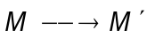 such that 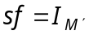.
(b) If and
are two exact sequence of R-modules with 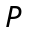, 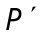 projective, prove that 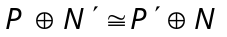.
(c) Prove that 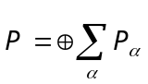 is projective 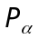 is projective for each . (6 + 6 + 8 = 20)
- (a) If 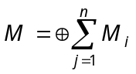 and 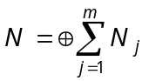 prove that 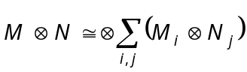.
(b) If is an exact sequence of R-modules, prove that for any R-module M, the sequence
is exact, where 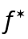 and 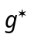 are defined by 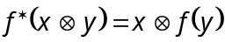 and 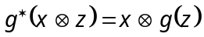.
(c) Prove that M is faithfully flat if and only if M is flat and for each maximal ideal m of R, 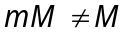.
(6 + 6 + 8 = 20)
- (a) Prove that an element 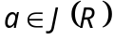 if and only if 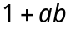 is a unit, for all 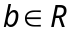.
(b) State and prove Chinese remainder theorem.
(c) If R is local ring, prove that any finitely generated projective R-module is free. (6 + 8 + 6 = 20)
- (a) If is an exact sequence of R-modules prove that  is Noetherian if and only both 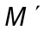 and 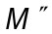 are Neotherian.
(b) If M is a Noetherian module prove that any irreducible submodule N of M is primary.
(c) If R is an Artinian ring prove that the nil radical N(R) is nilpotent. (8 + 6 + 6 = 20)
- (a) Let 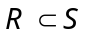 be domains and S integral over R. Prove that R is a field if and only if S is a field.
(b) Let R be an integrally closed domain with quotient field K and S a normal extension of R with Galois group G = G(L/K). Prove that
(i) 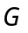 is the group of R-automorphisms of S
(ii) Two prime ideals and 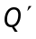 of S lie over the same prime ideals of R if and only if there exists some 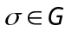 with 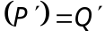.
(10 + 10 = 20)
- (a) If k is a field and R a finitely generated k-algebra prove that there exist 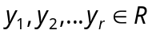 algebraically independent over k such that R is integral over 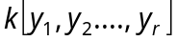.
(b) If R is a finitely generated k-algebra, k field and I an ideal of R, prove 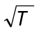is the intersection of all maximal ideals of R containing I.
(c) If R is a Noetherian integrally closed domain with quotient field K and L is a finite separable extension of K, prove that the integral closure S of R in L Noetherian. (6 + 6 + 8 = 20)
- (a) Prove that the ideals of a valuation ring are totally ordered by inclusion and prove that if the ideals of a domain V with quotient field K are totally ordered by inclusion then V is a valuation ring of K.
(b) If R is a subring a field K prove that the integral closure 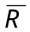 of R in K is the intersection of all valuation rings V of K containing R.
(c) Prove that the ring of integers in an algebraic number field is a Dedekind domain. (7 + 7 + 6 = 20)
- (a) Let M be a fractionary ideal of R. Prove that the following are equivalent :
(i) M is invertiable.
(ii) M is finitely generated and 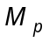 is invertible in 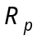 for every prime ideal P of R.
(iii) M is finitely generated and 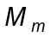 is invertible in 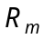 for every maximal ideal m of R.
(b) If R is a domain, prove that R is a Dedekind domain if and only if every non-zero fractionary ideal of R is invertible. (10 + 10 = 20)
–––––––––––––––
DE–932
12
DISTANCE EDUCATION
M.Phil. (Mathematics) DEGREE EXAMINATION, DECEMBER 2010.
MEASURE THEORY
(Upto 2006 Batch)
Time : Three hours Maximum : 100 marks
Answer any FIVE questions.
Each question carries 20 marks.
- (a) State and prove Lebesque’s Monotone convergence theorem.
(b) Show that if 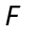 is any collection of subsets of  there exists a smallest – algebra in such that 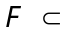ℳ*.
- State and prove Lebesque’s dominated convergence theorem.
- Let be a locally compact Hausdorff space in which every open set is – compact. Let the any positive Borel measure on such that 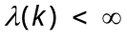 for every compact set k. Then show that is regular.
- (a) Define conjugate exponents.
(b) Let and be conjugate exponents 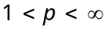. Let be a measure space with measure . Let and be measurable functions on with range in 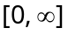. Then show that
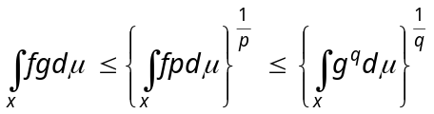 and
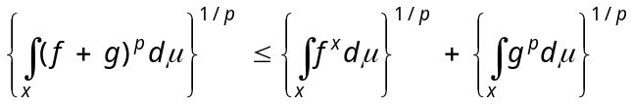
- (a) Suppose and are measures on a – algebra ℳ is positive, and is complex. Then show that the following two conditions are equivalent.
(i) 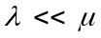
(ii) To every 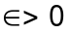 corresponds a 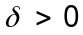, such that 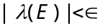 for all 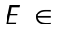ℳ with 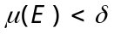.
(b) If is a positive -finite measure on a algebra ℳ in a set , then show that there is a function 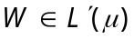 such that 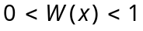 for every 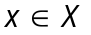.
- Suppose 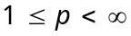, is a finite positive measure on 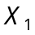 and is a bounded linear functional on 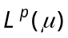. Then show that there is a unique 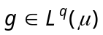 where is the exponent conjugate to such that 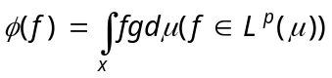.
- Let 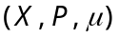 and 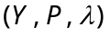 be a -finite measure spaces. Suppose 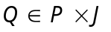. If 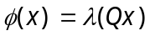, 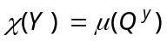 for every and 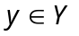 then show that 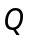 is measurable, is 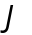 measurable and 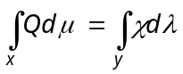.
- Suppose 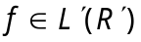, 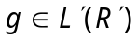. Then show that 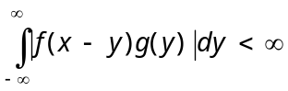 for almost all . For these , define 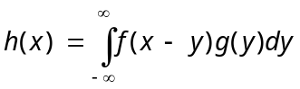. Then show that 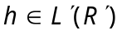 and 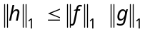 where 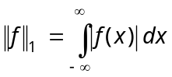.
–––––––––––––––
DE–933
13
DISTANCE EDUCATION
M.Phil. (Mathematics) DEGREE EXAMINATION, DECEMBER 2010.
TOPOLOGICAL VECTOR SPACES
(Upto 2006 Batch)
Time : Three hours Maximum : 100 marks
Answer any FIVE questions.
(5 × 20 = 100)
- (a) If Y is a subspace of a topological space X and Y is locally compact in the topology inherited from X, prove that Y is a closed subspace of X.
(b) Suppose Y is a subspace of a topological vector space X and Y is an F-space in the topology inherited from X, prove that Y is a closed subspace of X.
- (a) Suppose X and Y are topological vector spaces and 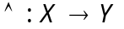 is linear. Consider the following statements :
(i) is continuous.
(ii) is bounded.
(iii) If 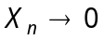 then { 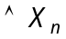 : n = 1,2,3,...} is bounded.
(iv) If then 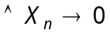.
Prove that (i) (ii) (iii) and if X is metrizable prove that (iii) (iv) (i).
(b) Prove that a topological vector space X is normable if and only if its origin has a convex bounded neighborhood.
- (a) If X and Y are topological vector spaces, K is a compact convex set in X, 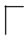 is a collection of continuous linear mappings of X into Y, and the orbits 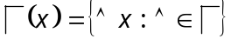 are bounded subsets of Y, for every 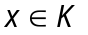 prove that there is a bounded set 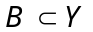 such that 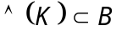for every 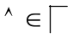.
(b) State and prove the closed graph theorem.
- (a) If X and Y are topological vector spaces and 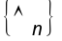 is a sequence of continuous linear mappings of X into Y, prove the following :
(i) If C is the set of all 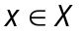 for which 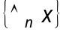 is a Cauchy sequence in Y and if C is of the second category in X then C = X.
(ii) If L is the set of all at which 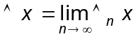exists, if L is of the second category in X and if Y is an F-space then L = X and is continuous.
(b) If 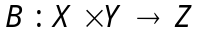 is bilinear and separately continuous, X is an F-space and Y and Z are topological vector spaces, prove that 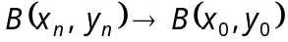 in Z when ever 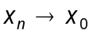 in X and 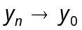 in Y. If Y is metrizable prove that B is continuous.
- (a) Suppose
(i) M is a subspace of a real vector space X.
(ii) 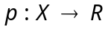 satisfies 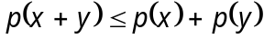 and 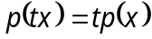 if 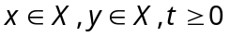.
(iii) 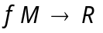 is linear and 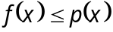 on M.
Prove that there exists a linear 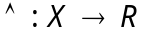 such that 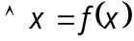 for 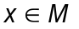 and 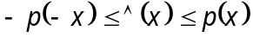 for .
(b) If f is a continuous linear functional on a subspace M of a locally convex space X, prove that there exists 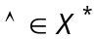 such that 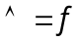 on M.
- (a) Prove that in a locally convex space X, every weakly bounded set is originally bounded and vice versa.
(b) Let H be the convex hull of a compact set K in a topological vector space X. Prove that (i) If X is a Frechet space, then H is compact and (ii) If 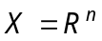then H is compact.
- (a) Suppose X and Y are normed space. Associate
to each 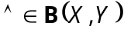 the number 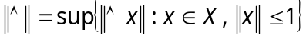. Prove that if Y is a Banach space, so is B (X, Y).
(b) If U and v are the open unit balls in the Banach spaces X and Y respectively and 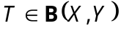and
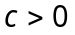, prove that if the closure of T(U) contains cV then  and if 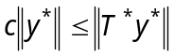 for every 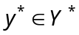 then 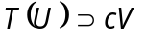.
- (a) Prove that on every compact group G there exists a unique regular Boral probability measure m which is left-invariant and right-invariant and it satisfies the relation 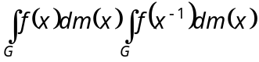 for 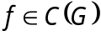.
(b) Suppose X is a Banach space, A and B are closed subspace of X and X = A + B. Prove that there exists a constant 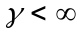 such that every has a representation 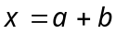, where 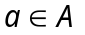, 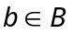 and 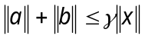.
———————
DE–934
14 (a)
DISTANCE EDUCATION
M.Phil. (Mathematics) DEGREE EXAMINATION, DECEMBER 2010.
FUNDAMENTALS OF DOMINATIONS IN GRAPH
(Upto 2006 Batch)
Time : Three hours Maximum : 100 marks
Answer any FIVE questions.
All questions carry equal marks.
(5 × 20 = 100)
- (a) Show that 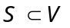 is a minimal dominating set if and only if every vertex in S has atleast one private neighbour.
(b) Show that for every connected graph G, rad (G) diam (G) 2 rad (G).
- (a) Show that if a graph G has no isolated vertices then 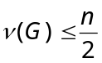.
(b) Show that if G is a connected graph and 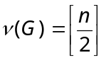 then there is at most one end vertex adjacent to each 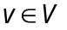 except for possible one vertex which may be adjacent to exactly two end vertices when n is odd.
- (a) Show that if a connected graph G is clear-force and net-free then 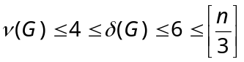.
(b) Show that for any tree T, 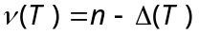 iff T is a wounded spider.
- (a) Show that if a graph G has no isolated vertices then 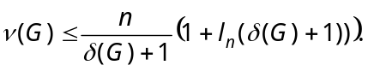
(b) Show that for any graph G and hereditary property 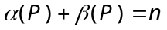.
- (a) Show that for any graph G, 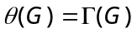.
(b) Show that each knockout-with-replacement sequence on a graph of order n size m terminates in atmost m steps.
- Show that efficient dominating is NP complete
(a) for bipartite graphs
(b) for chordal graphs
- (a) Show that if G is an r-regular graph then 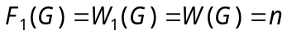.
(b) State and prove automorphism class theorem.
- State and prove necessary and sufficient conditions for a graph G to be a member of UVR.
————————
DE–935
14 (B)
DISTANCE EDUCATION
M.Phil. (Mathematics) DEGREE EXAMINATION,
DECEMBER 2010.
DATA STRUCTURES AND ALGORITHMS
(Upto 2006 Batch)
Time : Three hours Maximum : 100 marks
Answer any FIVE questions.
All questions carry equal marks.
- (a) Explain OOP Paradigm. (15)
(b) What are the benefits and applications of OOP? (5)
- (a) With an example C++ program explain operator overloading. (10)
(b) Explain different types of inheritance and use of access specifiers in inheritance. (10)
- (a) What is meant by complexity of an algorithm? Explain anyone notation. (10)
(b) Write and explain the algorithm for linear search.
(10)
- (a) How arrays are represented in memory? Explain address mechanism. (10)
(b) Explain the concept of linked list. (10)
- (a) Explain array implementation of stack. (10)
(b) Explain linked list representation of queue. (10)
- (a) Explain the binary tree representation of two-way linked list. (10)
(b) What is circular list? Explain its structure. (10)
- (a) Explain Prim's algorithm. (10)
(b) Explain the way of finding minimum spanning tree.
(10)
- Write short notes on the following
(a) Binary tree search. (6)
(b) Depth first search. (8)
(c) Merging. (6)

————————

